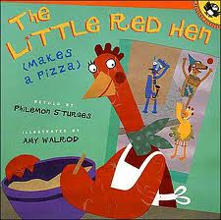
Resources
Here is a list of books to share with your children to help develop their sense of self:
Focus & Self- Control (need these skills in order to help achieve their goals)
- The Little Red Hen Makes a Pizza by Philomen Sturges
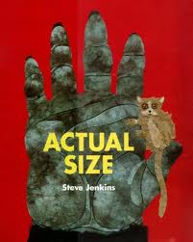
- The Art Lesson by Tomie dePaola
Perspective taking (teaching children basic social skills of developing an understanding of how others think and feel)
- Freedom Summer by Deborah Wiles
- Actual Size by Steve Jenkins
Communicating
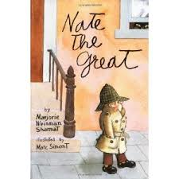
- Martin’s Big Words by Doreen Rappaport and Bryan Collier
- The Storyteller’s Candle by Lucia Gonzalez
Critical Thinking (useful in teaching children how to guide our own beliefs, decisions and actions)
-Nate the Great by Marjorie Weinman Sharmat
- Why Can’t I Be the Leader by Bailey & Pam Griacom
Taking On Challenges (instead of avoiding them)
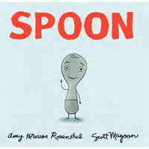
- Knuffle Bunny by Mo Willems
- Horton Hears a Who by Dr. Seuss
Self-esteem
- I Like Myself! by Karen Beaumont
- Spaghetti in a Hot Dog Bun by Maria Dismondy
- SPOON by Amy Krouse
(Reference: Mind In The Making. (n.d.). Retrieved from http://www.fbmarketplace.org/mitm)

